(Date)
Dear ________
Thank you for your very generous donation of $_______ to the Madera American Association of University Women (AAUW) scholarship program. Your donation helps support young women as they further their education and become community leaders.

AAUW is a non-profit organization (Tax ID# 68-0463071). The American Association of University Women, founded in 1881, is the nation's leading organization advancing equity for women and girls through advocacy, education, philanthropy and research.

Thank you again. Your support is making a difference in the lives of the young women of Madera.
Sincerely,

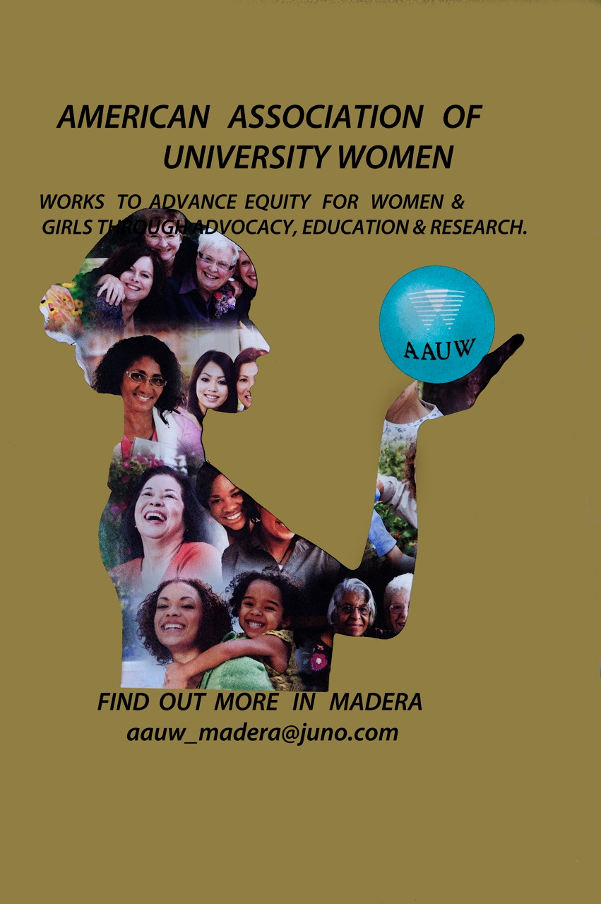

Website:madera-ca.aauw.net

